Jacob Mueller

2/18/2022

The most recent sprint for SNHU Travel project was admittedly a huge success, we had great feedback the whole way through and many of the teaching moments were followed up with substantial learning moments. The team was able to contend with any issues that came up, like the scope of the platform attending to user preference over wide selection. Utilizing agile methodology to great effect, we were able to pivot and adjust smoothly over the past 7 weeks. I want to thank everyone in our various roles for putting in so much effort and completing work on time.

Firstly, over the course of the project, the scrum master [Jacob Mueller] was responsible for conducting the meeting between the product owner and the development team, managing the conduct of the team using agile methodology, and overseeing daily standups, amongst other small duties like this retrospective.

The development team was responsible for developing the SNHU Travel program which, aside from the actual coding work, included discussions with the product owner, scrum master, team, and testers. The team’s daily standups and time estimation activities were also utilized to establish and maintain a smooth workflow and allow for natural team building outside of the workflow.

The product owner was responsible for managing the product backlog, meeting with the consumers/customers/stake holders/owners/users/etc. relaying information from the project’s status, discussing the project’s status with the development team and scrum master (the scrum master taking on the lion’s share of the discussion to convey the information more effectively), and refining user stories for the development team and testers.

Testers were responsible for managing the refining of user stories alongside the development team and, almost goes without saying, testing the product for any issues.

The product owner took the initial feedback and/or preferences from the “users” and compiled a selection of user stories for the development team to work with. Organizing the information uniformly across the first five user stories helped the team move forward as they began estimating the importance of the user stories. Work on accomplishing the tasks gleaned from the user stories began shortly after, the completed work was pushed along to the product owner and testers to make sure that the tasks were done correctly. Test cases were drafted for the testers to use, based on the user stories, listing expectations, directions for the tests, and expected outcomes.

After the initial user stories journey, the product owner was able to bring the status of the project to the users, get their feedback, and issue out new user stories. Any adjustments were within the team’s ability to complete because the scrum master was able to report the capabilities of the team, and the team was able to adjust their estimations on the stories and tasks. The adjusted stories also required some tweaking of the test cases and scenarios, in the future a portion of the daily standups or an announcement in the information hub will be provided so the team doesn’t feel as blindsided by the pivot. Attached to the report pages is a representation of this process which includes the initial user story and communication within the team, an email pertaining to changes made to the scope of the SNHU Travel project, and the revised stories with appropriate test cases.

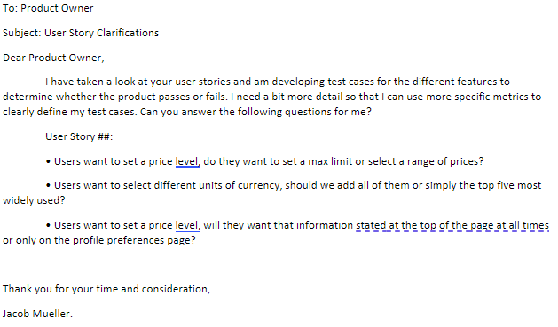

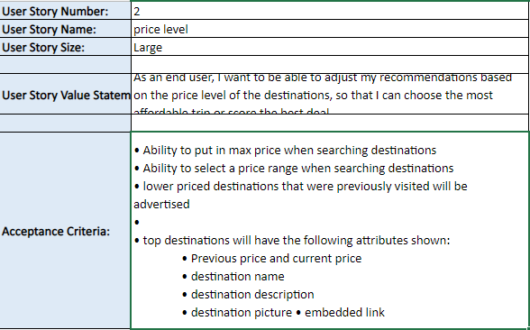

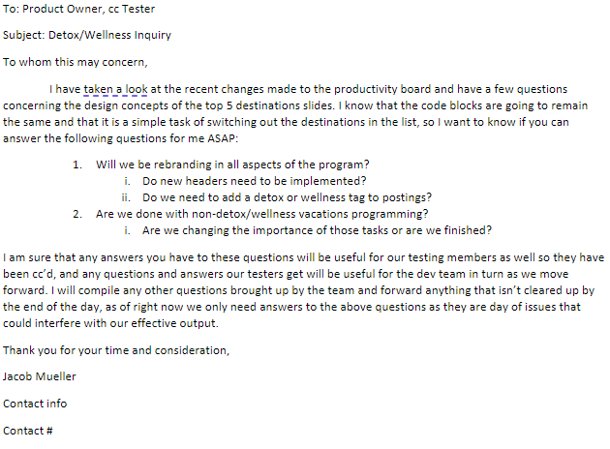

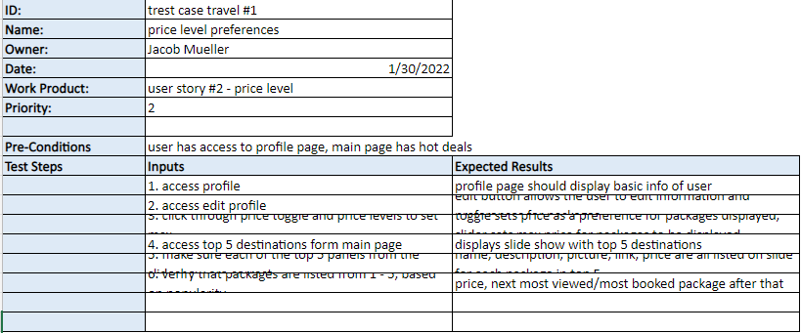

As previously stated, the adjustment period following the feedback from users that focused on more preferences being introduced on the platform was reconciled smoothly by the team. Having many chances to pivot as a team during the sprint was imperative to the team’s success, daily standup’s provided opportunities for the development team to voice concerns and suggest ideas for the team’s changes. Estimating the tasks by importance and difficulty meant that the team was able to work around the most important tasks first and put time aside to make the necessary adjustments.

Agile methodology itself maintains a vague concept framework for the project, which means there is no concrete plan in place for the team to follow, the project is ultimately reliant on the output of the team. Assessing and reassessing the capabilities, output and performance of the development team is a key part of the sprint, and colors the choices the management positions make as the project is pursued. Without a concrete plan and the workflow involved, it is easy for the team to effectively change direction with the project.

During the discussion on transitioning from waterfall methodology to agile methodology, the team made many suggestions concerning increased communication between team members.

Brightspace is a potent information radiator, with sections devoted to announcements, discussions, resources, and much more. It is a communal area for the team to “meet” in, even when the team is working remotely. In many ways it is like a traditional workplace information radiator like jinra, except jinra includes a kanban-esque system which works directly with agile methodology concepts. Personally, I am partial to using a physical whiteboard to display work orders and tasks, but I can see the appeal of the web-based information radiator. Namely, the fact that everyone should be able to communicate daily barring outages, which is a tenet of the agile manifesto; working together daily on the project, and it doesn’t say it has to happen in person. Going hand in hand with that is the principle of accepting and processing changes, and nothing makes my job easier than being able to see what is asked of me, provide an attempt at the task, take feedback, apply changes, and produce quality output that meets the requirements of the project simply by swapping between two web pages.

The main pros, in my mind, of using the scrum-agile approach to complete a project are having clear lines of communication between all involved parties, and many opportunities to change direction. It makes the most sense to use that perspective with a travel service, these are interesting times: weather patterns, covid, ukraine, winter olympics, Betty White, all those things and more are weighing on people and shaping the way the “travel” wind is blowing. Using the agile approach to glean, parse, and complete tasks based on end user input, with a review and reassessment of the end user input and performance of the team in order to perfect the product for the customers every ~30 days is the most beneficial. Let’s say that a waterfall approach would take the same amount of time on this project, 8 weeks or about 2 sprints, there is going to be a lot of time that is waiting to be filled or underutilized based on the initial planning process and lack of flexibility within the project. Agile, however, will have at least two different planning processes and no kibosh on pivoting to produce better output.

On the other hand, the agile approach can be too broad minded, meaning that if there aren’t enough resources to allow for the team to complete the project, the end user will be left with a lackluster result. For instance, let’s say that the agile team goes through two sprints on this travel project and spends 4 weeks coding the website, while the waterfall team would spend 8 full weeks working on a project. Maybe the 8 week project isn’t as specific to the customer base but it could end up being a lot more polished if the team is able to capitalize on their estimations in the initial planning process. It can be a very time-consuming venture as the team works with a vague framework, with the frequent testing and meetings the process can grow expensive.

Overall, with the way the project transformed midway through our sprint I would have to say that the agile methodology was imperative to our success, and I think that the end users would say the same thing. Having the ability to provide input and perceive the changes in the finished product tailored to those inputs is the best part of agile methodology.